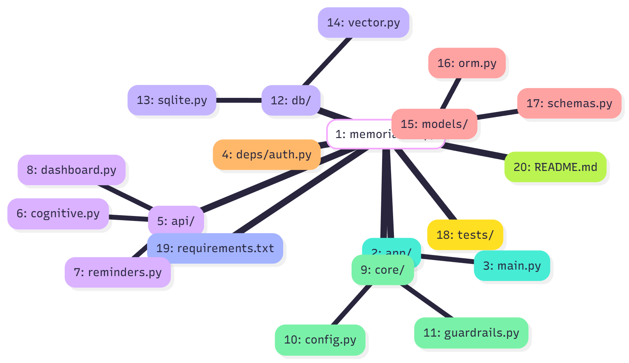Assignment 3 – API Service Designs & Architecture (MemoriAI)
Course: INFO8665 – Projects in Machine Learning
Team: Group 3 (MemoriAI) – Tessa Nejla Ayvazoglu, Krishna Reddy Bovilla, Adhitya Kondeti, Bhupender Sejwal, Kumari Nikitha
Date: October 2025

Table of Contents
- Executive Summary
- System Context
- Use Case 1 – Cognitive & Identity Assist
- Use Case 2 – Daily Reminders & Safety
- Use Case 3 – Caregiver Dashboard
- Data Layer & Security
- Deployment & Operations
- Key Flows
- Appendix – OpenAPI Snippets, Risk Matrix & References

1. Executive Summary
MemoriAI is an AI-powered assistive system supporting Alzheimer’s care through three core pillars: Cognitive & Identity Assist, Daily Reminders & Safety, and Caregiver Dashboard. Each use case includes three alternative API service designs (REST, Microservice, Event-Driven) to evaluate scalability, modularity, and safety.

2. System Context
Figure 1 – System Context Diagram
Caption: System context showing external actors and internal services within the secure cloud environment.



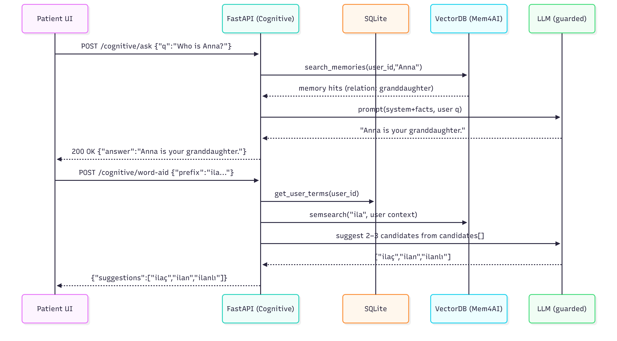Figure 2 – MVP Architecture
Caption: MVP architecture with modular REST services connected via API Gateway in Azure.

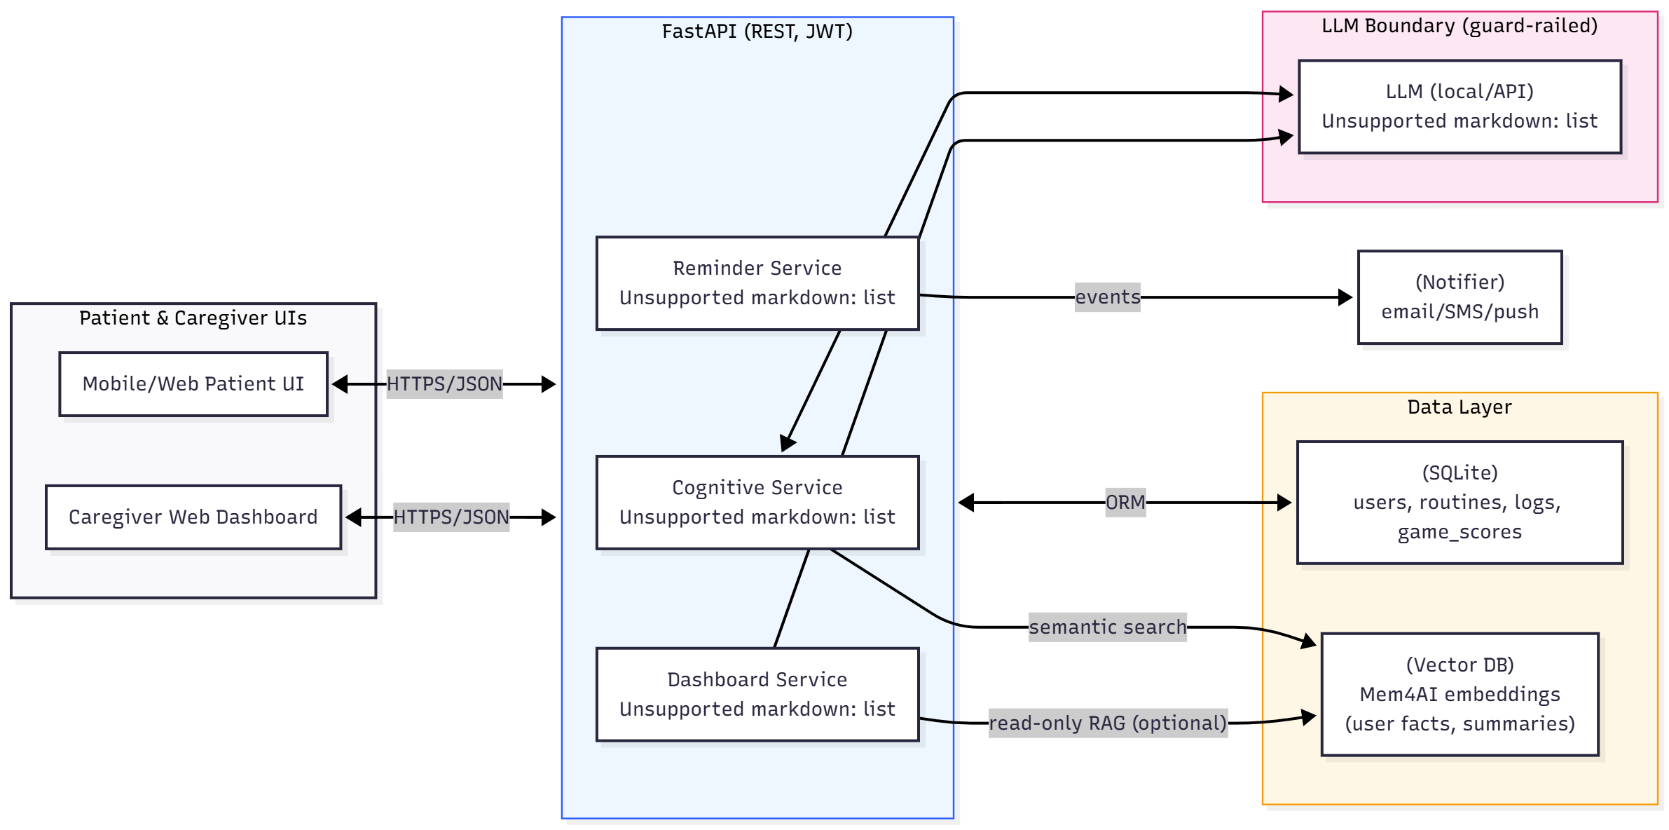

3. Use Case 1 – Cognitive & Identity Assist
Goal: Support memory recall and word association safely through explainable AI.
Primary Actor: Patient
Secondary Actor: Caregiver
Figure 3 – Cognitive & Identity Flow
Caption: Cognitive & Identity Assist flow representing fact recall and word-aid suggestion through RESTful APIs.
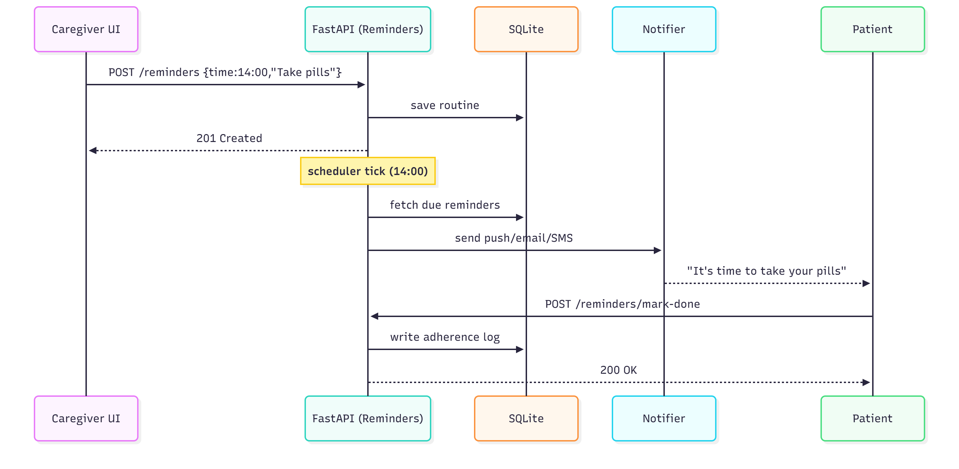

3.1 API Service Designs (Use Case 1)

Design #1 – Synchronous REST (MVP Implementation)
Endpoints: /cognitive/ask, /cognitive/word-aid
Stack: FastAPI, LangChain, SQLite, Vector DB
Security: OAuth2 + JWT, RBAC roles (patient/caregiver)
Low latency (<1.5s p95)

Design #2 – Split Microservices (Cognitive Core + LLM Adapter)
Public core API delegates phrasing to a private LLM adapter. Strong data boundary (no PII exposure). Scalable and safer.

Design #3 – Event-Driven Async Design
POST /cognitive/ask (async) returns job_id. GET /cognitive/jobs/{job_id} fetches results later. Queue or worker ensures retry and audit logging.
Figure 4 – Design Comparison Table
Caption: Comparison of 3 API service designs for Cognitive & Identity Assist.

Design # | Architecture Type | Core Routes & Functions | Key Components / Tech | Security & Data Controls | Pros / Cons / When to Use
1. Synchronous REST | Classic RESTful FastAPI service | /cognitive/ask, /cognitive/word-aid | FastAPI, LangChain, SQLite, Vector DB | OAuth2 + JWT, RBAC, TLS, PII minimization | ✅ Simple, fast for MVP❌ Tightly coupled
2. Split Microservices | Cognitive Core + LLM Adapter | Same routes; adapter handles phrasing | FastAPI, Docker, internal REST bus | RBAC per service, short-lived tokens | ✅ Safe boundaries, scalable❌ More setup
3. Event-Driven Async | REST front + worker queue | POST /cognitive/ask (async) → job_idGET /cognitive/jobs/{id} | FastAPI, Queue/Worker, SQLite | JWT scopes, audit trails, retries | ✅ Reliable & observable❌ More complexity

4. Use Case 2 – Daily Reminders & Safety
Figure 5 – Daily Reminder Flow
Caption: Flow of reminder scheduling, adherence logging, and caregiver notification.


5. Use Case 3 – Caregiver Dashboard
Figure 6 – Caregiver Dashboard Daily Summary
Caption: Caregiver Dashboard summarizing patient adherence, cognitive trends, and notifications.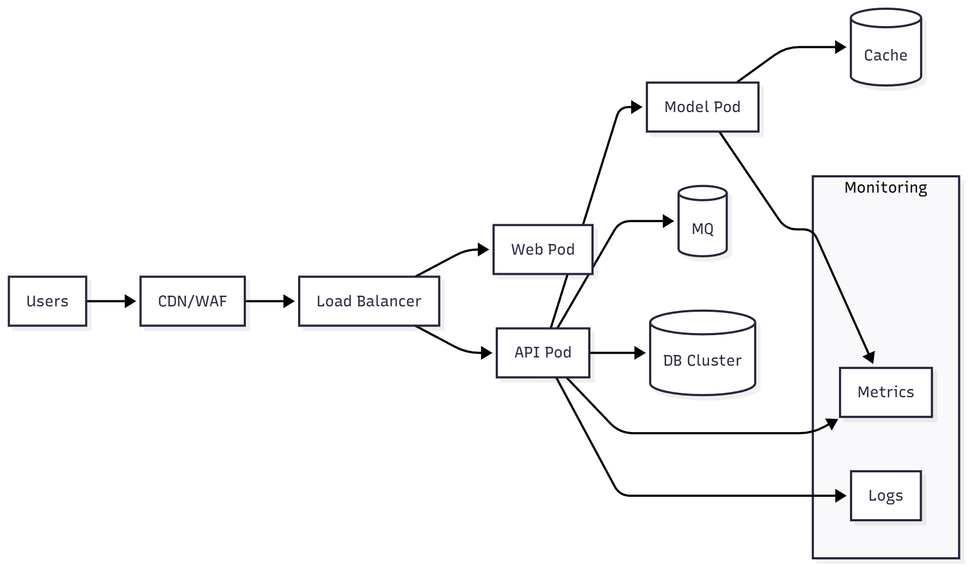
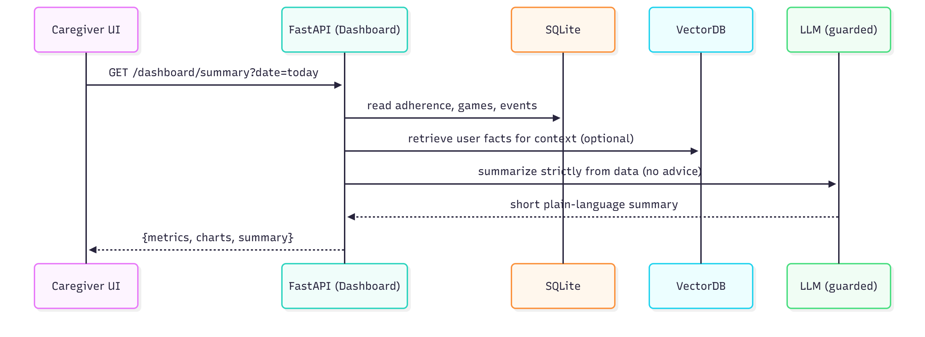

6. Data Layer & Security
Core Entities: users, routines, adherence_logs, game_scores, mem4ai_embeddings
Security Controls:
- OAuth2 + JWT
- RBAC (patient/caregiver/admin)
- TLS 1.3, SQLite encryption
- Audit logs & guardrails

7. Deployment & Operations
Figure 7 – Deployment Architecture
Caption: Azure deployment with containerized FastAPI microservices and CI/CD pipeline.
CI/CD via GitHub Actions → Docker → Azure App Service. Health checks, metrics, logging, and environment isolation (Dev/Test/Prod).

8. Key Flows
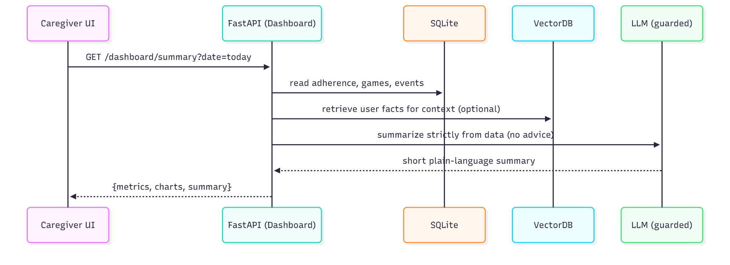
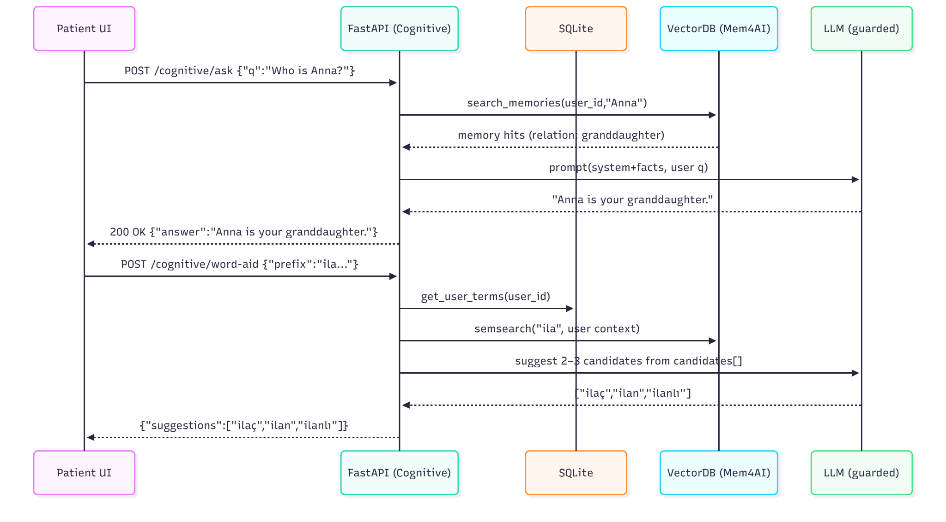
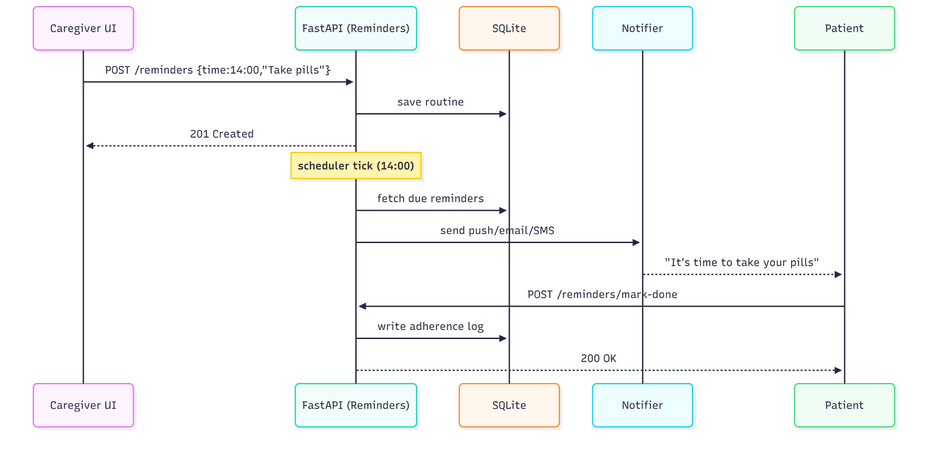

9. Appendix – OpenAPI Snippets, Risk Matrix & References

1. OpenAPI Snippets
Below are example API contract snippets representing MemoriAI’s main service endpoints. These follow the OpenAPI-style format to illustrate request and response structures for the MVP design.
- Example – Cognitive Ask API
POST /cognitive/ask
Summary: Retrieve factual identity information
Request Example:
{
"q": "Who is Anna?"
}
Response Example:
{
"answer": "Anna is your granddaughter."
}
- Example – Daily Reminder API
POST /reminders
Summary: Create a new reminder for a patient
Request Example:
{
"time": "14:00",
"text": "Take your medicine"
}
Response:
201 Created
- Example – Async Job API
POST /cognitive/ask (async)
Request Example:
{
"q": "Who is Anna?",
"mode": "async"
}
Response:
202 Accepted
{
"job_id": "cog_7f9a1234"
}
GET /cognitive/jobs/{job_id}
Response Example:
{
"status": "done",
"answer": "Anna is your granddaughter."
}

2. Risk Matrix
The following table outlines key technical and operational risks for MemoriAI’s MVP phase, with their likelihood, impact, and mitigation strategies.
Risk | Likelihood (1–5) | Impact (1–5) | Priority (L×I) | Mitigation | Owner
LLM hallucination | 2 | 5 | 10 | Facts-only recall, guardrails, manual testing | AI Lead
Reminder delivery failure | 3 | 4 | 12 | Retries, acknowledgements, synthetic monitoring | Backend Dev
PII leakage | 2 | 5 | 10 | Data minimization, encryption, RBAC, audits | Security
Scope creep | 4 | 3 | 12 | MVP gating, sprint control | Project Manager
Single-node failure | 2 | 4 | 8 | Health checks, restart policies, backups | DevOps

3. References
The following documents and external sources were referenced during the development of the MemoriAI architecture and API design:
- MemoriAI – High-Level Design (HLD) v1, 2025.
- MemoriAI – High-Level Design (HLD) v2 (Advanced Actors), 2025.
- MemoriAI – Architecture Overview, 2025.
- Alzheimer’s Association (2024). Dementia Facts & Figures.
- Brookmeyer et al. (2018). Forecasting Global Burden of Alzheimer’s Disease.
- Etters et al. (2008). Caregiver stress in Alzheimer’s disease.
- Nature (2024). Empowering caregivers with AI.

